**Project Design Phase-II**

**Data Flow Diagram & User Stories**

|  |  |
| --- | --- |
| Date | 4 June 2025 |
| Team ID | LTVIP2025TMID38840 |
| Project Name | CleanTech: Transforming Waste Management with Transfer Learning |
| Maximum Marks | 4 Marks |

**Data Flow Diagrams:**

This data flow diagram illustrates a complete user interaction cycle for an AI-powered application. The process begins when a user uploads an image via the web application's frontend. The frontend then sends the image within an HTTP request to the backend server. The backend server preprocesses this image and sends it to a Deep Learning (DL) model, which in turn returns a prediction result. This result is sent back to the frontend through an HTTP response, allowing the result page to be displayed to the user. As an optional final step, the backend server can log the prediction into a database**.**

**Example:** [**(Simplified)**](https://developer.ibm.com/patterns/visualize-unstructured-text/)

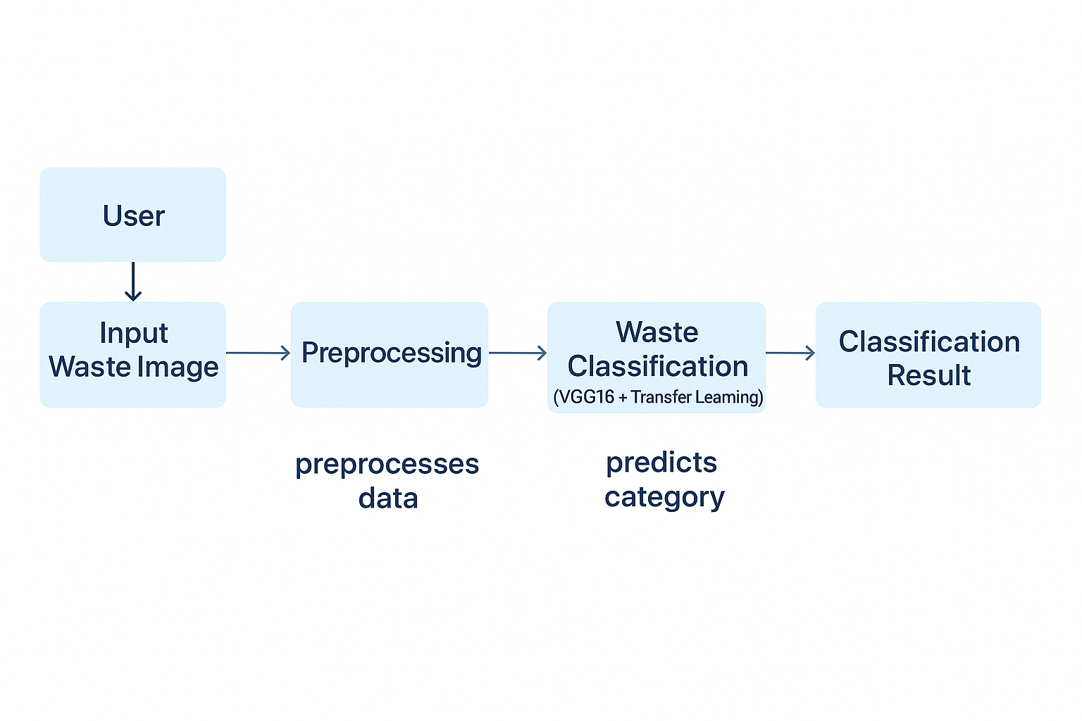

**User Stories**

Use the below template to list all the user stories for the product.

User stories break down the Cleantech project into small, manageable tasks from the perspective of each user. They help our team focus on building features that provide real value, such as a live dashboard for the Facility Manager, downloadable reports for the Municipal Director, and hardware alerts for the Maintenance Technician. By addressing these specific needs, we ensure the final system is practical, user-focused, and successfully solves the intended challenges in waste management.

| **User Type** | **Functional Requirement (Epic)** | **User Story Number** | **User Story / Task** | **Acceptance criteria** | **Priority** | **Release** |
| --- | --- | --- | --- | --- | --- | --- |
| Facility Manager | Real-time Monitoring | USN-1 | As a Facility Manager, I want to view a live dashboard of the sorting process so that I can monitor operational efficiency. | Dashboard displays key metrics like items sorted per minute, purity rates, and system uptime. | High | Sprint-1 |
| System | Waste Classification | USN-2 | As the system, I want to automatically classify waste materials from the camera feed to enable automated sorting. | The model classifies common materials (e.g., PET, cardboard) with >95% accuracy and sends results to the control system. | High | Sprint-2 |
| Maintenance Technician | System Health Alerts | USN-3 | As a Maintenance Technician, I want to receive an immediate alert if a camera or robotic arm reports a fault to minimize downtime. | An email/SMS alert is sent to a designated contact within 2 minutes of a critical hardware error. | High | Sprint-2 |
| Facility Manager | Performance Analytics | USN-4 | As a Facility Manager, I want to view historical performance trends so that I can identify areas for improvement. | The dashboard allows viewing and comparing recycling rates and costs over daily, weekly, and monthly periods. | Medium | Sprint-1 |
| Municipal Director | Report Download | USN-5 | As a Municipal Director, I want to download a summary performance report so that I can track ROI and compliance. | A report (PDF/DOCX) with key metrics can be downloaded successfully. | Medium | Sprint-3 |
| AI Engineer | Model Management | USN-6 | As an AI Engineer, I want to upload a new dataset to retrain the model so that I can improve its accuracy over time | System provides an interface to upload a labeled dataset and initiate a retraining job. | Medium | Sprint-4 |